**Git Pull from Eclipse**

# Steps to Pull from Eclipse

1. Go to Eclipse 🡪right Click on project to pull the changes done in the project from Git repo.
2. Select Teams🡪Select pull

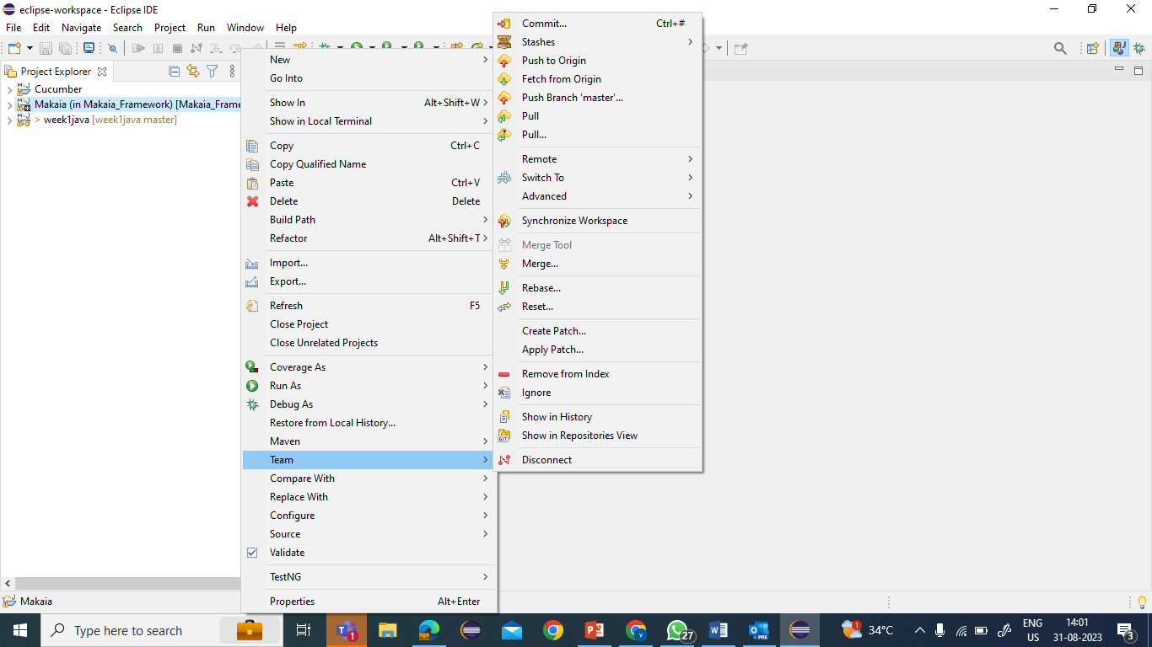

1. A pop window with master branch of the Git repo

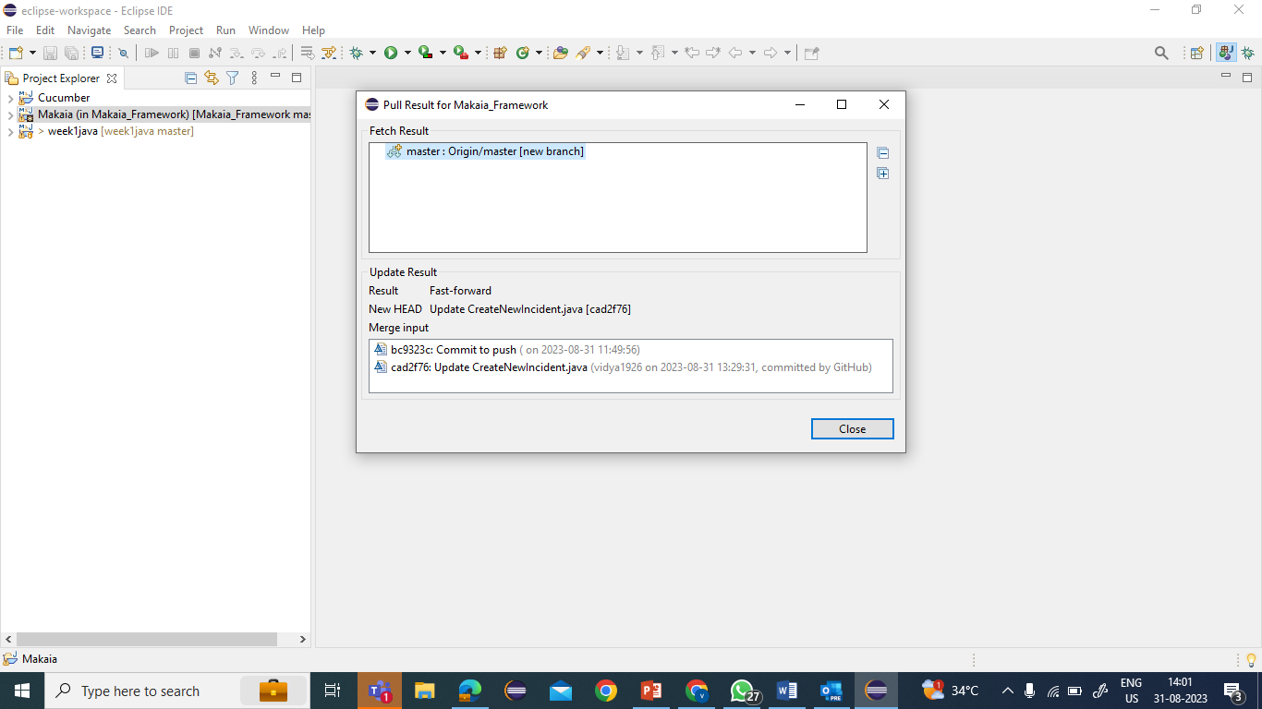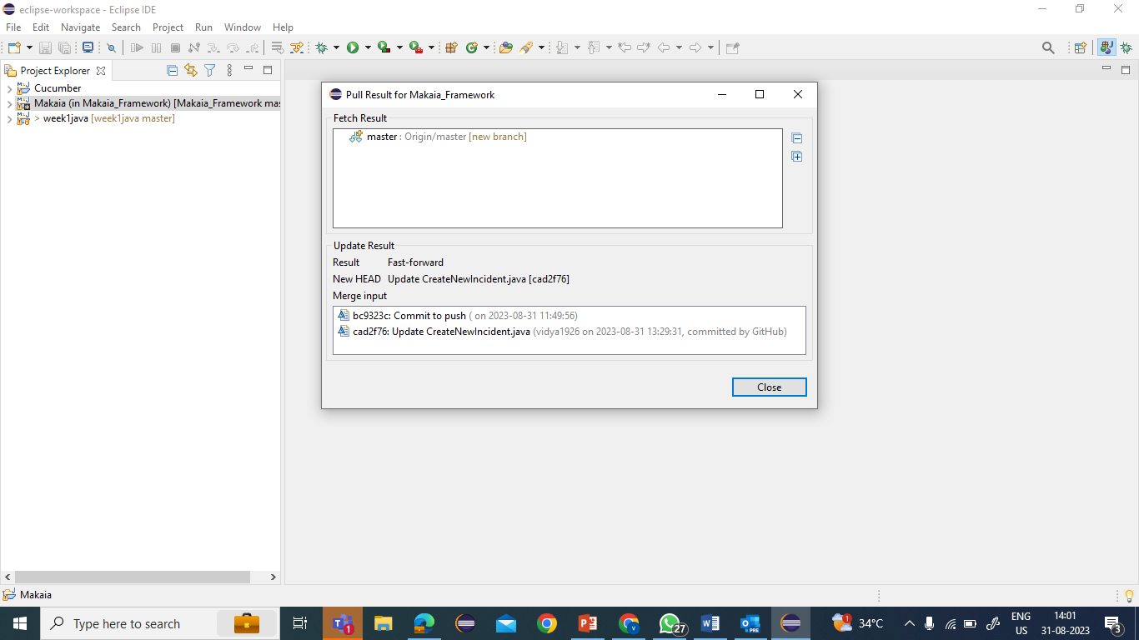

1. Confirm the project changes are pulled successfully

